Institution: International Burch University

Date : June 2025

**Course Title:**  
Introduction to E-Business / E-Commerce

**Course Code:** ***IT 3008***  
**Instructor:** Amela Vatres, Samed Jukic

Rare Sneakers and Streetwear Marketplace

Kerim Senderovic, Muhamed Tukulic

**Table of content**

Introduction ………………………………………………………………………………………………………………………………………….1

Unique characteristics …………………………………………………………………………………………………………………………..1

Common E-Commerce Elements …………………………………………………………………………………………………………..2

Customer Buying Persona ……………………………………………………………………………………………………………………..8

Competitive Analysis …………………………………………………………………………………………………………………………….12

LOGO and Company name. …………………………………………………………………………………………………………………..13

BUSINESS MODEL ………………………………………………………………………………………………………………………………..13

Business Strategies ……………………………………………………………………………………………………………………………….15

Revenue Model for "Rare Shoes and Streetwear" ………………………………………………………………………………….16

Milestone 2. WordPress e-commerce website ……………………………………………………………………………………….19

Functional Requirements ……………………………………………………………………………………………………………………….19

Non-Functional Requirements ……………………………………………………………………………………………………………….21

PLUGINS ………………………………………………………………………………………………………………………………………………..22

Milestone 3: Advertising and Reporting………………………………………………………………………………………………… 27

Introduction …………………………………………………………………………………………………………………………………………..27

Marketing & Advertising Plan …………………………………………………………………………………………………………………27

Ethical Considerations & Compliance ……………………………………………………………………………………………………..27

SEO Optimization ……………………………………………………………………………………………………………………………………30

Social Media Promotion ………………………………………………………………………………………………………………………….33

Paid Advertising Campaigns …………………………………………………………………………………………………………………….40

Email Marketing ……………………………………………………………………………………………………………………………………..42

SMS Campaign ……………………………………………………………………………………………………………………………………….45

Google Analytics & Insights ……………………………………………………………………………………………………………………46

Lessons Learned & Reflections ……………………………………………………………………………………………………………….46

SWOT Analysis & Future Opportunities …………………………………………………………………………………………………..47

**Introduction**

Rare Sneakers & Streetwear Marketplace is an exclusive online platform designed for sneaker enthusiasts and streetwear collectors. Our mission is to connect buyers and sellers worldwide, offering a trusted space to buy, sell, and trade limited-edition sneakers and high-end streetwear. With a focus on authenticity, community engagement, and seamless transactions, we aim to revolutionize the sneaker resale market.

**Unique characteristics**

**Ubiquity** Your marketplace will be accessible 24/7 from any location via desktop and mobile devices. Sneaker enthusiasts can browse and purchase limited-edition sneakers from anywhere, ensuring convenience and a seamless shopping experience.

1

**Global Reach** Your platform will allow buyers and sellers from different countries to engage in transactions. This expands the customer base beyond local sneaker communities, enabling rare sneaker collectors worldwide to participate.

**Universal Standards** The marketplace will use standardized payment gateways such as PayPal, Stripe, and cryptocurrency options to facilitate global transactions. Standardized web protocols ensure compatibility across devices and browsers.

**Richness** The platform will feature high-quality images, 360-degree views, and video content for each sneaker, allowing users to inspect details before purchasing. Unboxing videos and product authenticity verification visuals will enhance user trust.

**Interactivity** Live chat support and AI-powered chatbots will assist buyers and sellers with inquiries about sneaker authenticity, price negotiations, and order tracking. A social forum for discussions on streetwear trends will also drive engagement.

**Information Density** The marketplace will provide detailed product descriptions, seller ratings, and price comparison features. A historical price tracking tool will help users analyze sneaker value trends over time.

**Personalization & Customization** AI-driven recommendations will suggest sneakers based on users' browsing history, purchase behavior, and wishlist items. Users can also customize their storefronts, creating a personalized selling experience.

**Social Technology** Integration with social media platforms like Instagram and TikTok will allow users to share purchases, reviews, and listings. Influencer collaborations and community engagement through exclusive drops and giveaways will enhance brand visibility and credibility.

**Common E-Commerce Elements**

 For our Rare Sneakers & Streetwear Marketplace, the following e-commerce elements will be implemente*d:*

* **Easy-to-use navigation**: A clean and intuitive menu layout for seamless browsing.
* **Strong security**: End-to-end encryption, secure payment gateways, and two-factor authentication.

2

* **Powerful search and filtering**: Advanced filters for brand, size, condition, and price range.
* **High-quality content**: Professional sneaker photography, detailed descriptions, and verification insights.
* **Chatbot / customer support**: 24/7 AI chatbot assistance and human support for queries.
* **Strong product descriptions with images**: Verified seller listings with high-resolution images and descriptions.
* **Customer reviews**: User-generated ratings and testimonials for authenticity assurance.
* **Fast, simple checkout**: One-click checkout, multiple payment options, and express shipping.
* **Wishlist**: Save favorite sneakers for future purchase or price drop notifications.
* **FAQ**: A dedicated FAQ section addressing common queries and policies.

**Mockups** To visualize the platform, mockups will be created for the following:

* **Homepage**: Featuring trending sneakers, top sellers, and latest arrivals.
* **Product Page**: Detailed sneaker images, description, price, size selection, and reviews.
* **Search & Filter Page**: Advanced search functionality with multiple filtering options.
* **Checkout Page**: A simple, secure, and efficient checkout process.
* **User Dashboard**: Personalized account settings, wishlist, order history, and selling options.

3

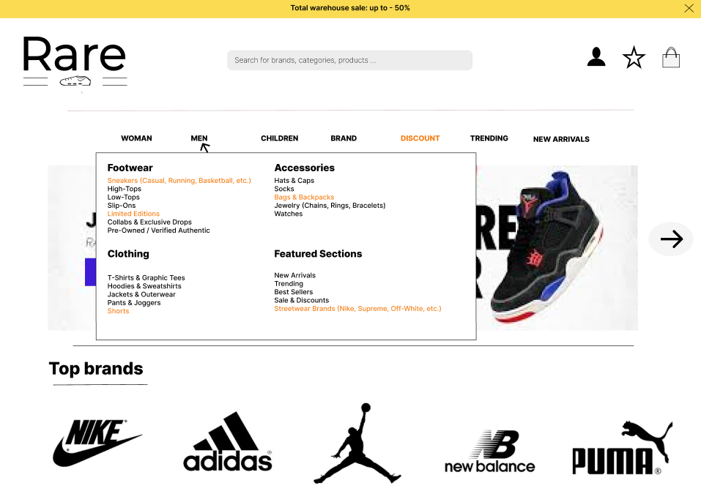

4

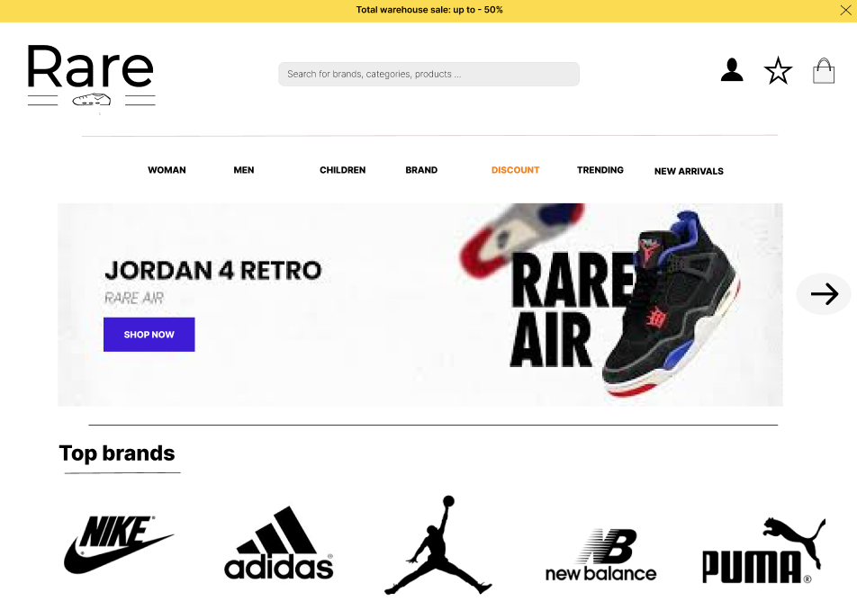

5

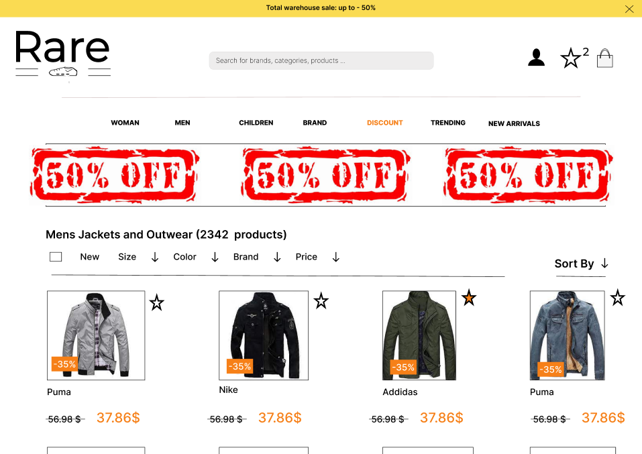

6

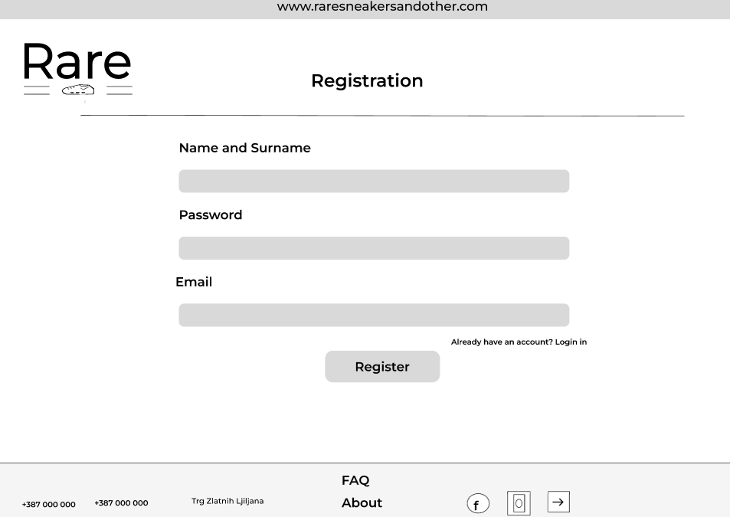

7

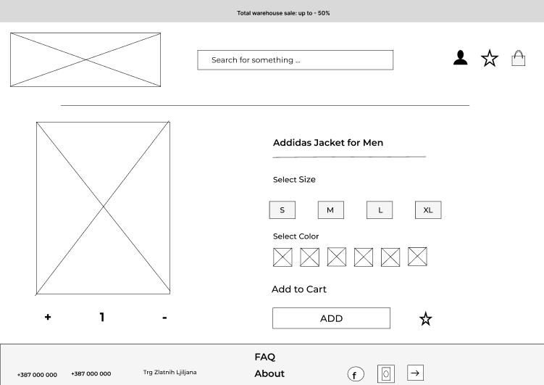

**Customer Buying Persona**

**Who are they?**  
Sneaker collectors, streetwear enthusiasts, and resellers looking for exclusive, limited-edition footwear and apparel.

**Age Range:**  
18-35 years old

**Gender:**  
Primarily male, but also female streetwear enthusiasts.

**Location:**  
Urban areas, primarily in sneaker culture hotspots such as the U.S., Europe, and Asia.

**Income Level:**  
Mid to high income (students, young professionals, sneaker resellers, and collectors).

**Occupation or Industry:**  
Students, young professionals, fashion enthusiasts, influencers, and sneaker resellers.

8

**Education Level:**  
High school to college graduates.

**What do they care about?**

* Authenticity and exclusivity of sneakers.
* Fast and secure transactions.
* Sneaker resale value and investment potential.
* Trending fashion and streetwear culture.

**Main Interests & Hobbies:**

* Collecting and trading sneakers.
* Following sneaker drops and brand collaborations.
* Engaging with streetwear and urban fashion communities.
* Watching sneaker review content on YouTube and TikTok.

**Values & Beliefs:**

* Passionate about sneaker culture and individuality.
* Trend-conscious and brand-loyal.
* Tech-savvy and prefers seamless online shopping experiences.

**Problems & Challenges:**

* Difficulty finding rare or limited-edition sneakers.
* Overpriced resale market.
* Long shipping times and high transaction fees.

**Lifestyle Preferences:**

* Active and fashion-driven.
* Luxury-conscious but also budget-aware for investments.
* Brand-driven and prefers high-status sneakers.

9

**Preferred Brands:**  
Nike, Adidas (Yeezy), Jordan, Off-White, Supreme, Travis Scott collaborations.

**Media Consumption:**

* Social media (Instagram, TikTok, Twitter, Reddit).
* Sneaker blogs (Hypebeast, Highsnobiety, Complex).
* YouTube sneaker unboxings and reviews.
* Fashion podcasts and influencer content.

**Shopping Habits:**

* Prefers online shopping via Shopify, StockX, GOAT, or eBay.
* Relies on Google, Instagram, and YouTube for recommendations.
* Compares products using influencer reviews and customer feedback.
* Shops frequently, especially during major sneaker drops.

**Where They Spend Time Online:**

* Instagram and TikTok for sneaker inspiration.
* Reddit sneaker communities and Discord groups.
* YouTube for sneaker-related content.

**Buying Decision Drivers:**

* Product authenticity and verification.
* Limited-edition status and exclusivity.
* Competitive pricing and resale value.
* Fast shipping and hassle-free returns.

**Objections Before Purchasing:**

* Price concerns.
* Trust in seller authenticity.

10

* Shipping costs and delays.
* Return and refund policies.

This customer persona will help shape the user experience, marketing strategies, and platform features for maximum engagement and conversion.

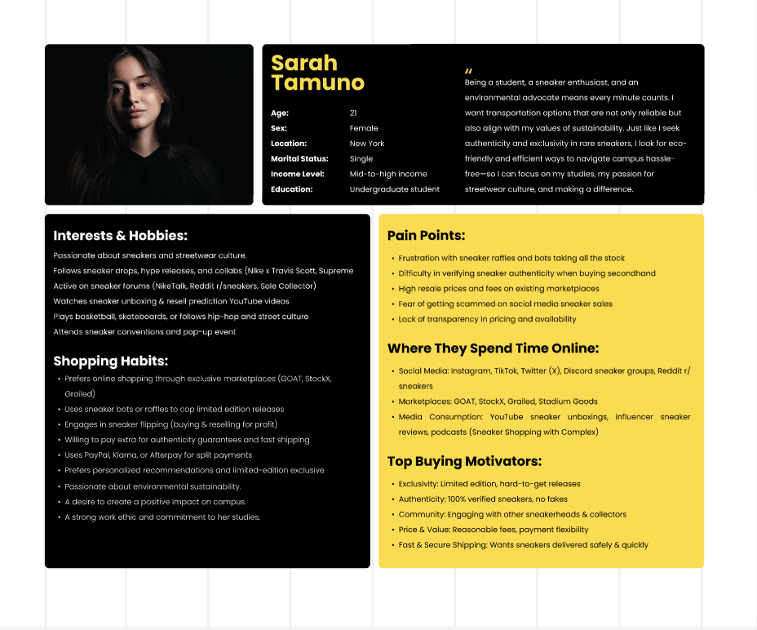

11

**Competitive Analysis**

**Main Competitors**

|  |  |  |
| --- | --- | --- |
| **Competitor** | **Strengths** | **Weaknesses** |
| **StockX** | Global brand recognition, strong authentication process, transparent pricing | High fees, slow payout for sellers |
| **GOAT** | Offers new & used sneakers, strong authentication, mobile-friendly | High fees, shipping can take long |
| **Flight Club** | Premium marketplace, physical stores in NYC & LA, high-end inventory | Very high prices, limited seller access |
| **KLEKT** | |  | | --- | |  |  |  | | --- | | Europe-based, strong authentication, good UI | | High seller fees, slower customer service |
| **Secret Sneaker Store** | Australian-based, good local presence, trusted marketplace | Limited international reach, high prices |

**How You Can Compete & Stand Out**

**Lower Seller Fees** – Offer competitive fees to attract more sellers.

**Faster Authentication & Payouts** – Improve the speed of verifying sneakers and releasing funds to sellers.  
**Exclusive Drops & Partnerships** – Work with smaller brands, influencers, or local sneaker stores for exclusive releases.  
**Community-Driven Platform** – Focus on user engagement, social media marketing, and forums for discussions.  
**Better UI & UX** – Ensure a seamless experience with better filtering, navigation, and checkout process.

121

**LOGO and Company name.**



**BUSINESS MODEL**

### **Business-to-Consumer (B2C)**

The B2C model involves selling directly to individual customers. In this model, our platform would source rare shoes and clothing from suppliers or brands and sell them directly to customers.

**Why Use It?**

* **Control Over Inventory & Pricing** – We can set product prices, control stock levels, and manage product availability.
* **Better Customer Experience** – Since customers buy directly from our platform, we can ensure product authenticity, offer warranties, and provide better service.
* **Marketing & Branding** – We can build brand loyalty through social media, influencers, and promotions.

### **Consumer-to-Consumer (C2C)**

The C2C model enables users to buy and sell directly among themselves, with our platform acting as a marketplace. We would facilitate transactions, ensuring trust and authenticity.

**Why Use It?**

13

* **No Need for Own Inventory** – Users list their rare shoes and clothes, so we don’t need to manage stock.
* **Scalability** – The platform can grow quickly as more people join to sell their own rare items.
* **Commission-Based Revenue** – We can charge transaction fees on each sale, making money without owning products

### **Best suitable Business model for our project is hybrid (B2C + C2C) model.**

A **hybrid (B2C + C2C) model** is ideal because it allows:  
 - Selling our own rare inventory (B2C).  
 - Allowing users to resell rare items (C2C).  
 - Offering authentication and transaction security.  
 - More inventory variety, trust, and scalability.

This approach maximizes growth, customer engagement, and revenue potential.

14

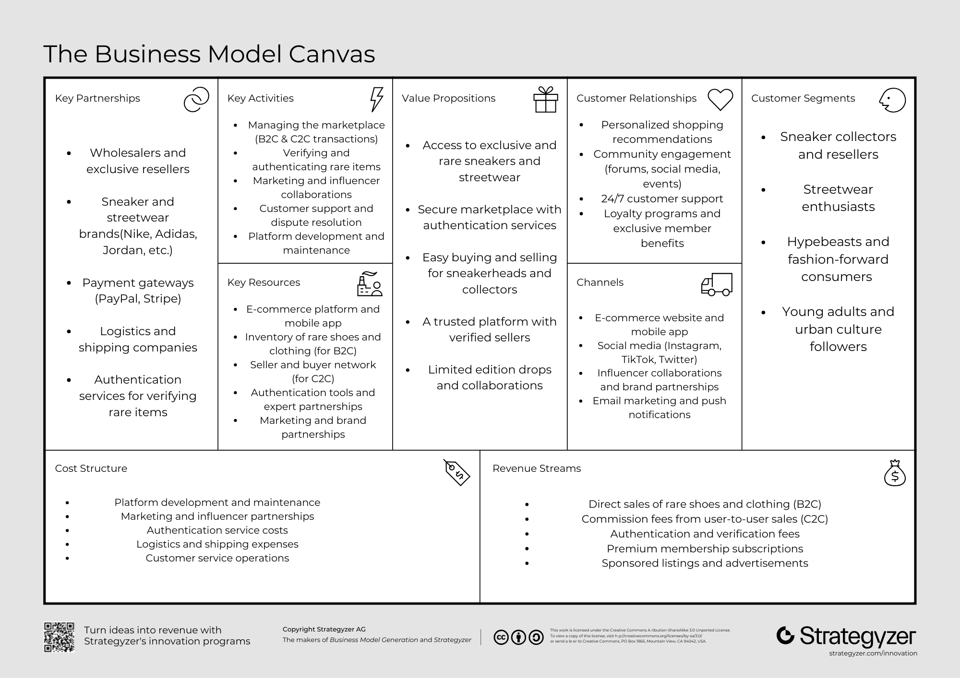

**Business Strategies**

To establish a competitive edge in the rare sneakers and streetwear marketplace, our strategy incorporates **differentiation, niche focus, and customer intimacy** to create a unique and loyal community of sneaker enthusiasts and streetwear collectors.

**1. Differentiation Strategy**

We will differentiate our marketplace by offering:

* **Exclusive & Verified Inventory** – Partnering with top-tier resellers and collectors to ensure authenticity and scarcity.

15

* **Premium User Experience** – A sleek, modern platform with intuitive navigation and personalized recommendations.
* **Content & Community Engagement** – Integrating sneaker/streetwear news, style guides, and influencer collaborations to enhance brand loyalty.

**2. Niche Focus Strategy**

Our focus is on a **highly engaged niche** of sneaker collectors and streetwear fans who seek rare, limited-edition items. We will cater to this segment by:

* Curating **hard-to-find** sneaker drops and exclusive apparel.
* Offering **priority access** to VIP members for new releases and restocks.
* Providing **high-end resale opportunities** for collectors and sellers.

**3. Customer Intimacy Strategy**

Building strong relationships with customers will be key to long-term success. We will:

* Implement a **personalized shopping experience** with AI-driven recommendations.
* Offer **high-touch customer service**, including sneaker authentication and buyer protection.
* Develop a **loyalty program** that rewards frequent buyers and trusted sellers.

**Competitive Advantage**

By combining differentiation, niche focus, and customer intimacy, our marketplace will stand out as **the go-to platform for rare sneakers and premium streetwear**, fostering a **trusted, engaged, and exclusive** community.

### **Revenue Model for "Rare Shoes and Streetwear"**

#### **1) Direct Sales (B2C Model)**

* The platform purchases or partners with brands to sell exclusive rare shoes and streetwear.
* Profit margin is earned on each sale

16

#### **2) Commission on Resale (C2C Model)**

* When users sell rare items to each other, the platform takes a **transaction fee (e.g., 5-15%)** from the final price.

#### **3) Authentication & Verification Fees**

* Buyers can pay an **optional fee** (e.g., $10–$50) for product authentication before purchase.
* Ensures trust and reduces counterfeit risks.

#### **4) Premium Membership Subscriptions**

* Offer **VIP membership** with benefits like:
  + Early access to limited edition drops.
  + Lower transaction fees on C2C sales.
  + Free or discounted authentication services.
  + Exclusive deals and discounts.
* Example: **$9.99/month or $99/year** subscription model.

#### **5) Featured Listings & Advertisements**

* Sellers can **pay to promote** their listings for better visibility.
* Example: **$5–$20 per listing for premium placement.**
* Brands can advertise on the platform via banners, sponsored posts, or influencer marketing.

#### **6) Shipping & Handling Fees**

* If the platform handles logistics, a **shipping fee** can be charged to the buyer.
* Option to partner with logistics providers for special discounted shipping rates.

### **Projected Revenue Breakdown**

17

| Revenue Stream | Expected Contribution (%) |
| --- | --- |
| Direct B2C Sales | 40% |
| C2C Commission Fees | 25% |
| Authentication Fees | 10% |
| Premium Memberships | 10% |
| Featured Listings & Ads | 10% |
| Shipping & Handling | 5% |

### **Why This Model Works?**

### **- Diversified income** – Not relying only on sales; multiple revenue streams increase stability. - **Scalability** – As more users join, transaction fees and premium subscriptions grow. - **Customer engagement** – Offering authentication and memberships builds trust and brand loyalty.

**RARE Business and Marketing strategy mix 4 p’s.**

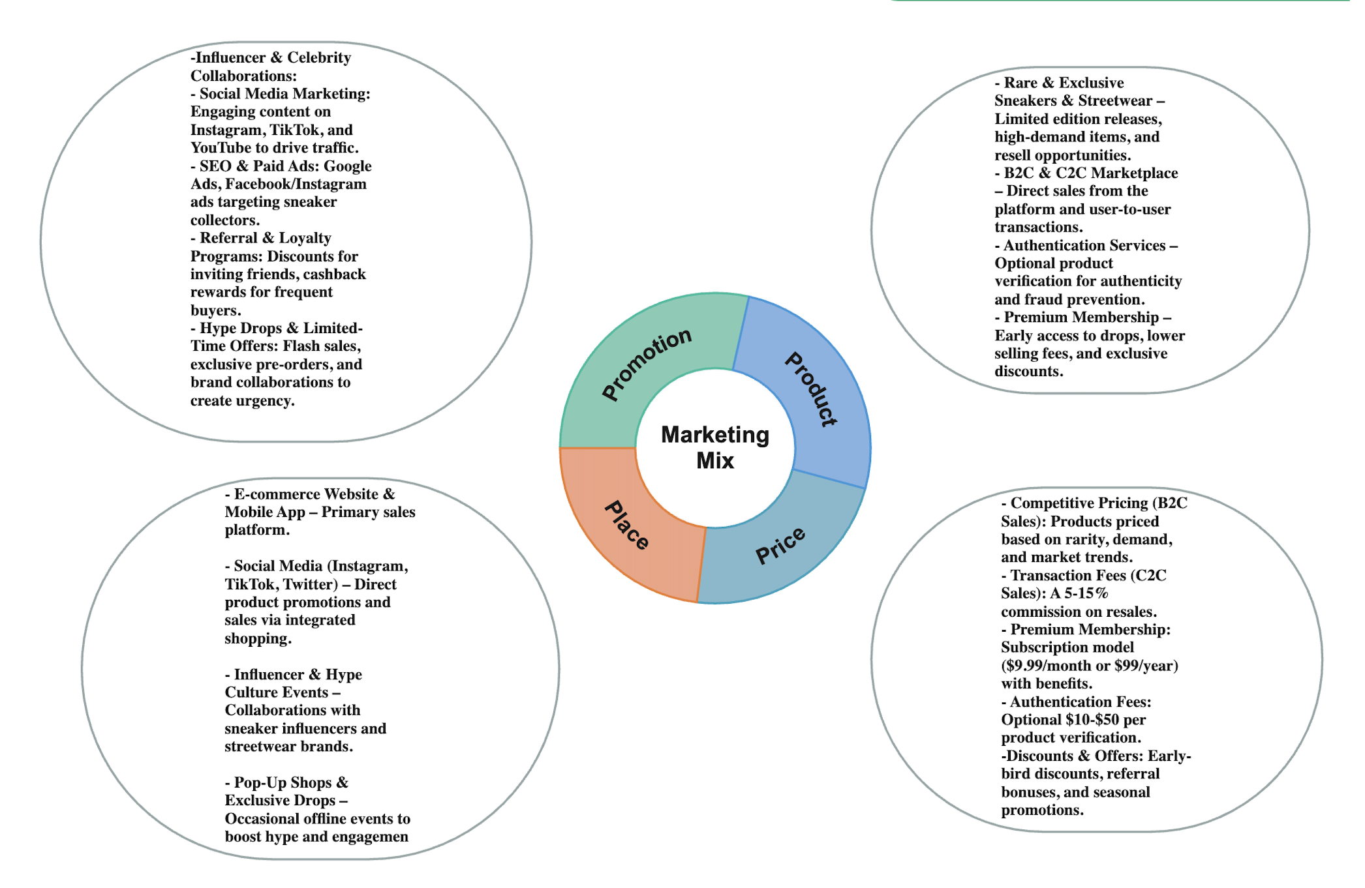

18

**Milestone 2. WordPress e-commerce website**

URLS :

Checkout - https://kerim1.ct.ws/checkout/

Cart - https://kerim1.ct.ws/cart/

Home - https://kerim1.ct.ws/home/

Account - https://kerim1.ct.ws/my-account/

Shop - https://kerim1.ct.ws/shop/

Product - https://kerim1.ct.ws/product/fragment-aj1/

Admin Url:

URL : <http://kerim1.ct.ws/wp-admin>

Username: Kerim

Password : Sarajevo123

**Functional Requirements**

**User Management:**

* User registration, login/logout
* 2FA (Two-Factor Authentication)
* CAPTCHA for spam/bot protection
* Login attempt limit & lockouts

**E-commerce Functionality:**

* Add/remove products from cart
* Checkout process
* Product pages with details (name, price, images, etc.)

19

* Product catalog with filters and search
* Reviews and ratings for products
* Inventory management

**Payment Integration:**

* Stripe and PayPal payment gateways

**Shipping & Taxes:**

* Shipping zones and methods configured
* Tax rules applied based on user location

**Upselling & Cross-selling:**

* Show related/upsell/cross-sell products

**Security Features:**

* SSL certificate for HTTPS
* Activity logs

**SEO & Optimization:**

* SEO plugin setup (like Yoast or Rank Math)
* Meta titles and descriptions added

**Backup System:**

* Automated backup schedule and restoration options

20

**Navigation:**

* Navigation menu with logical structure
* Search and filtering system

**Non-Functional Requirements**

**Performance:**

* Website loads efficiently on both desktop and mobile
* Optimized images and scripts

**Scalability:**

* Can handle increased number of users/products without performance drop

**Security:**

* Encrypted data transmission (SSL)
* Protection from brute force attacks
* CAPTCHAs and lockouts to reduce bot abuse

**Usability:**

* Mobile-responsive design
* Clear navigation and intuitive interface
* Consistent styling as per wireframes

21

**Maintainability:**

* Backups and logs to help recover from issues
* Plugin architecture allowing easy updates

**Availability:**

* High uptime hosting
* Fail-safes like automated backups

**Compatibility:**

* Works on all modern browsers and mobile devices

**PLUGINS**

1. Advanced Google reCAPTCHA

* Function: Protects your website from spam and brute-force attacks by adding a reCAPTCHA to forms (login, comment, etc.).
* Benefit: Prevents bots from submitting forms and improves security.

2. Akismet Anti-spam

* Function: Automatically filters out spam comments and form submissions.
* Benefit: Keeps your website free from spam and saves time by filtering out malicious content.

3. AppMySite

* Function: Syncs your WordPress/WooCommerce site with native iOS/Android apps.
* Benefit: Allows you to convert your website into mobile apps easily, improving mobile user experience.

4. Complianz - Terms and Conditions

22

* Function: Generates Terms & Conditions pages for your website.
* Benefit: Ensures your site is legally compliant by providing essential legal documentation.

5. Complianz | GDPR/CCPA Cookie Consent

* Function: Manages cookies and privacy regulations (GDPR, CCPA).
* Benefit: Helps ensure compliance with privacy laws by adding a customizable cookie consent banner.

6. Contact Form 7

* Function: Adds a simple and flexible contact form to your site.
* Benefit: Allows users to easily contact you through a customizable form.

7. Customer Reviews for WooCommerce

* Function: Collects and displays customer reviews for your products.
* Benefit: Increases trust and sales by allowing customers to leave and view reviews.

8. Elementor

* Function: A page builder plugin for drag-and-drop design and content creation.
* Benefit: Makes it easy to design custom pages without coding knowledge.

9. Google for WooCommerce

* Function: Integrates WooCommerce with Google Shopping and other Google services.
* Benefit: Allows you to display your products across Google’s network and drive traffic.

10. Hello Dolly

* Function: Displays random lyrics from the song "Hello, Dolly" in the WordPress admin area.
* Benefit: A lighthearted and fun plugin that is typically used for demonstration purposes.

23

11. Image Optimizer - Compress, Resize, and Optimize Images

* Function: Automatically resizes, compresses, and optimizes images for better site performance.
* Benefit: Reduces page load time by optimizing images, improving user experience.

12. Limit Login Attempts Reloaded

* Function: Limits the number of failed login attempts to protect your site from brute-force attacks.
* Benefit: Enhances security by blocking repeated failed login attempts.

13. MailPoet

* Function: Allows you to create and send newsletters, post notifications, and welcome emails.
* Benefit: Helps with email marketing and communication with your site’s users.

14. Max Mega Menu

* Function: Adds a customizable mega menu to your WordPress site.
* Benefit: Improves site navigation and user experience with a large, organized menu system.

15. Newsletter, SMTP, Email Marketing and Subscribe forms by Brevo

* Function: Handles email marketing and subscription forms.
* Benefit: Manages email campaigns, contact lists, and subscription forms.

16. Pinterest for WooCommerce

* Function: Integrates WooCommerce with Pinterest for tracking conversions and creating product Pins.
* Benefit: Expands your reach by enabling Pinterest integration for product promotion.

17. Product Filter by WBW

* Function: Adds advanced filtering options for products on your WooCommerce store.

24

* Benefit: Helps users easily filter products based on attributes like price, size, color, etc.

18. Really Simple Security

* Function: Provides a range of security features, including two-factor authentication and login protection.
* Benefit: Improves site security by hardening the WordPress installation and preventing unauthorized access.

19. Royal Elementor Addons

* Function: Adds additional widgets and features for Elementor page builder.
* Benefit: Extends Elementor’s functionality with advanced design elements.

20. Smart Slider 3

* Function: Adds responsive sliders to your site.
* Benefit: Allows you to create visually engaging sliders for showcasing products, promotions, etc.

21. Spectra

* Function: Enhances the Gutenberg editor with new blocks and design features.
* Benefit: Expands Gutenberg’s capabilities and helps create beautiful content with ease.

22. UpdraftPlus - Backup/Restore

* Function: Provides automatic backups and restores for your WordPress site.
* Benefit: Helps protect your site data by creating backup copies, ensuring recovery in case of issues.

23. W3 Total Cache

* Function: Optimizes site performance by caching and minifying resources.
* Benefit: Speeds up your website by improving load times and reducing server load.

25

24. WooCommerce

* Function: Powers your online store by providing product management, cart, and checkout functionalities.
* Benefit: Core e-commerce functionality for selling products, managing inventory, and processing orders.

25. WooCommerce PayPal Payments

* Function: Integrates PayPal as a payment gateway in your WooCommerce store.
* Benefit: Allows customers to pay using PayPal, enhancing the payment options on your site.

26. WooCommerce Stripe Gateway

* Function: Allows you to accept payments via Stripe on your WooCommerce store.
* Benefit: Offers secure credit card payment processing and global payment options.

27. Wordfence Security

* Function: Provides comprehensive website security with firewall, malware scanning, and login protection.
* Benefit: Secures your website from attacks and vulnerabilities.

28. Yoast SEO

* Function: Optimizes your website’s SEO, including on-page content analysis, meta tags, and sitemaps.
* Benefit: Improves your site’s search engine ranking and visibility.

26

## **Milestone 3: Advertising and Reporting**

### **1. Introduction**

This report outlines the advertising and marketing strategies implemented over a 3-week period for the Rare Sneakers and Streetwear e-commerce platform. The focus was to promote our limited-edition products, increase brand visibility, and drive conversions through a targeted, multi-channel digital marketing strategy.

### 2**. Marketing & Advertising Plan**

Objectives:  
- Increase traffic and conversions  
- Retain customers and build hype around drops  
- Build a loyal community  
  
Channels: Social Media, Paid Ads, Email, SMS ,  
  
Buyer Personas:  
- Hype Hunter  
- Flex Influencer  
- Sneaker Reseller

### **Ethical Considerations & Compliance**

Task 1: Privacy Compliance Checklist Report – Rare Sneakers and Streetwear

Summary of Data Collection Points:

* Website Forms: Collect name, email address, optional phone number, and product-related inquiries.
* Ad Campaigns & Pixels: Collect user engagement, session behavior, referral source, and purchase events through Meta Pixel and Google Ads tags.

27

Types of Data Collected:

* Personally Identifiable Information (PII): Name, email, phone (optional), and location (for delivery & analytics purposes).

Consent Handling:

* Consent is collected and stored for:
  + Newsletter sign-ups (checkbox before submission).
  + Order form submission.
  + Use of cookies (via cookie consent banner on site).
* Users can withdraw consent at any time via:
  + “Unsubscribe” links in emails
  + Contact email provided in the privacy policy.

User Awareness:

* A clear Privacy Policy is linked in the footer, detailing how data is used.
* Contact details for privacy questions are present.
* Privacy Policy Link: Included on the website and references contact emails:  
  + Muhamed.tukulic@stu.ibu.edu.ba
  + Kerim.senderovic@stu.ibu.edu.ba
* Unsubscribe functionality for email communication is handled via Mailchimp or similar email services.

Task 2: Social Report – Ethical Targeting & ADA Compliance

Targeting Strategy Ethics:

* Previous urgency-focused phrases like *“Only 1 pair left!”* have been adjusted.
* New messaging emphasizes uniqueness, style impact, and long-term value rather than pressure or scarcity.

Inclusivity in Visuals:

28

* Instagram and Facebook campaigns now include models of diverse ethnicities, genders, and styles.
* Visuals use bold, high-contrast elements for accessibility and aesthetics.
* Product descriptions avoid jargon, slang, or stereotypes.

Handling Sensitive Topics:

* No content exploits financial or mental health anxieties.
* No messaging aimed at “status” or social pressure.
* Promotions are based on community stories and authentic expression.

ADA Compliance Summary:

* All product and ad images have ALT TEXT for screen readers.
* Website uses contrast-enhanced buttons and headings (meets WCAG 2.1 AA).
* Navigation is fully keyboard accessible.
* All forms are properly labeled and testable by screen readers.

Task 3: Regulations Report – Legal & Political Considerations

Chosen Regulations:

1. GDPR – European Data Regulation
2. CAN-SPAM Act – U.S. Email Regulation

GDPR Summary:

* Requires clear user consent, transparency, and user rights access.
* Rare Sneakers ensures:
  + Consent Banners for cookies and marketing.
  + Right to delete or request data outlined in policy.
  + Secure storage and retention policy with data encryption.

CAN-SPAM Summary:

* Requires:
  + Clear sender identity in emails.

29

* + Easy opt-out options.
  + No false or misleading subject lines.
* Rare Sneakers compliance:
  + All emails include business contact info.
  + Unsubscribe link is available on every email.
  + Email content matches subject line expectations.

Additional Notes:

* Your brand avoids targeting:
  + Minors (ages under 16).
  + Addictive or harmful products.
  + Political or misleading claims.
* Focus is strictly on style, expression, and rarity in the sneaker/streetwear market.

### 3. SEO Optimization

Implemented meta titles and descriptions, ALT tags, optimized headers, mobile responsiveness, and keyword strategy.  
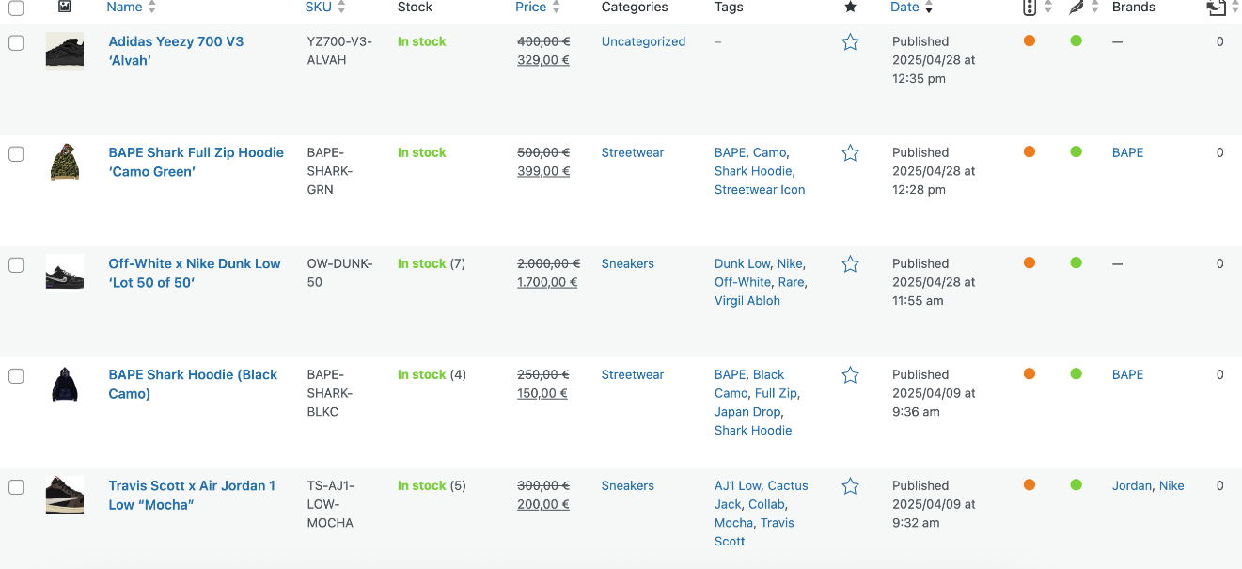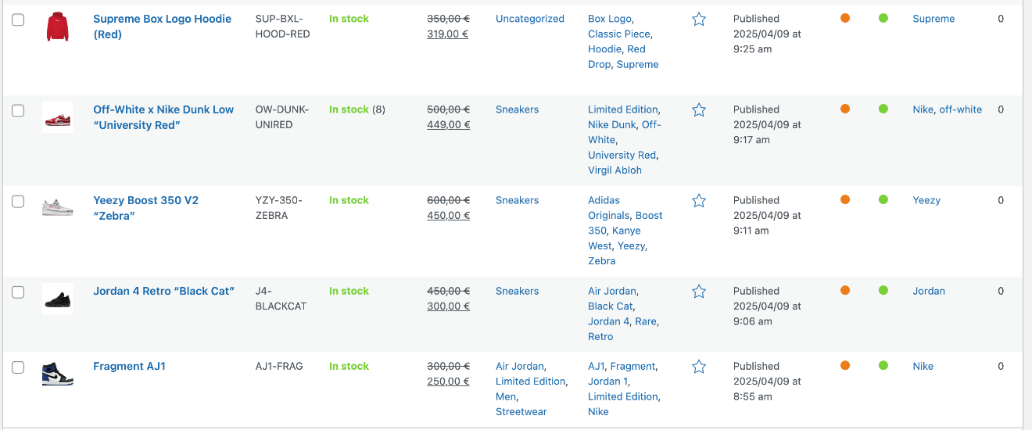

30

31

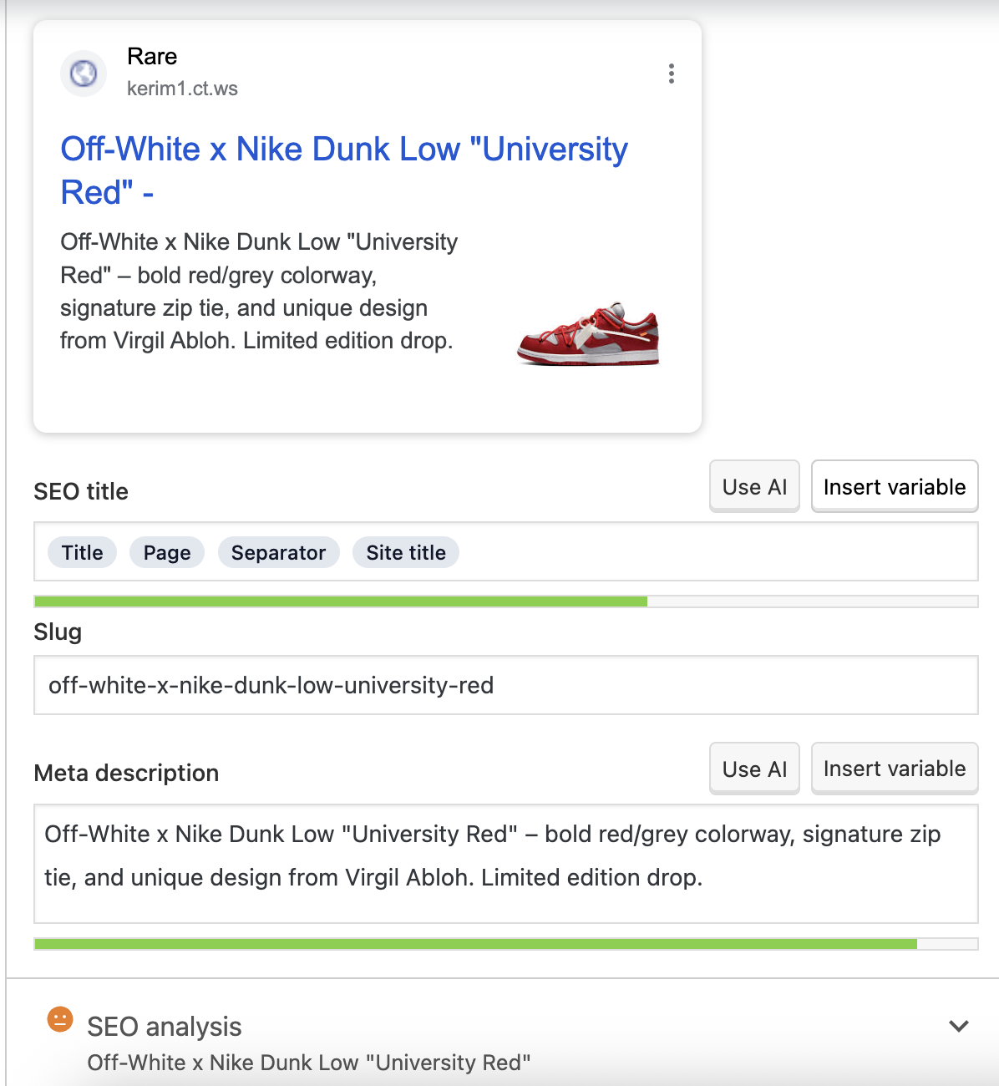

32

### 4. **Social Media Promotion**

Created Facebook, Instagram profiles.

**Platform Activity**

**Instagram for Business**  
The Instagram business profile is fully optimized with a concise brand bio, link to the online store, and clear contact buttons.  
The content strategy focuses on:

* Limited-edition sneaker drops
* Streetwear styling reels
* Behind-the-scenes footage from exclusive releases and sneaker conventions
* Customer spotlights showing unique fits and sneaker hauls

Popular hashtags like #RareKicks, #StreetwearDrop, #SneakerHype, and #CopOrDrop enhance reach and engagement.  
Instagram Insights are consistently reviewed to track post performance, reach, and engagement trends, helping fine-tune the posting schedule.

**Facebook Page**  
The Facebook business page features a clean, branded profile photo and a banner showcasing the latest drop or featured collaboration.  
Regular content includes:

* Introduction to the brand’s mission (limited, exclusive, hype-focused)
* Featured sneakers of the week and styling ideas
* Countdown posts for upcoming releases and early access announcements

33

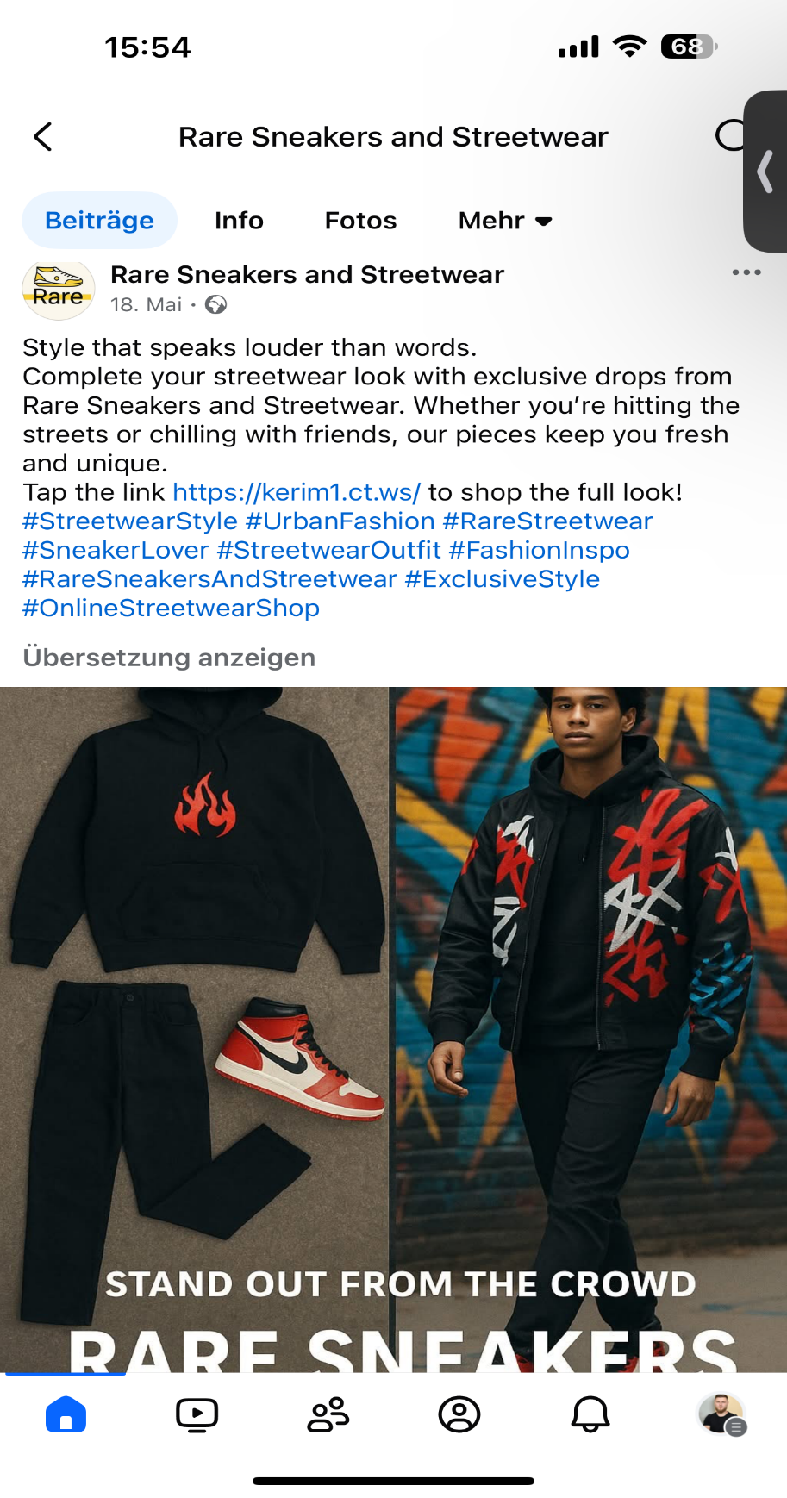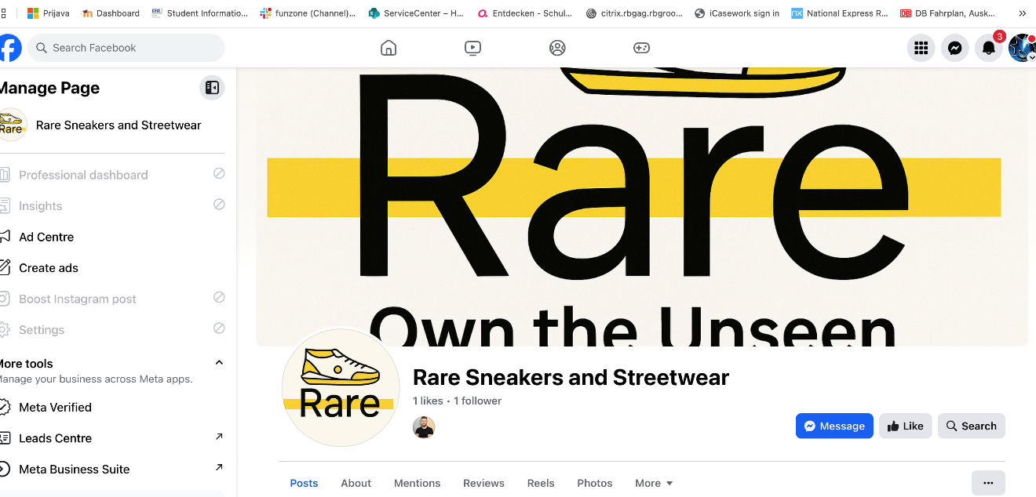

34

35

36

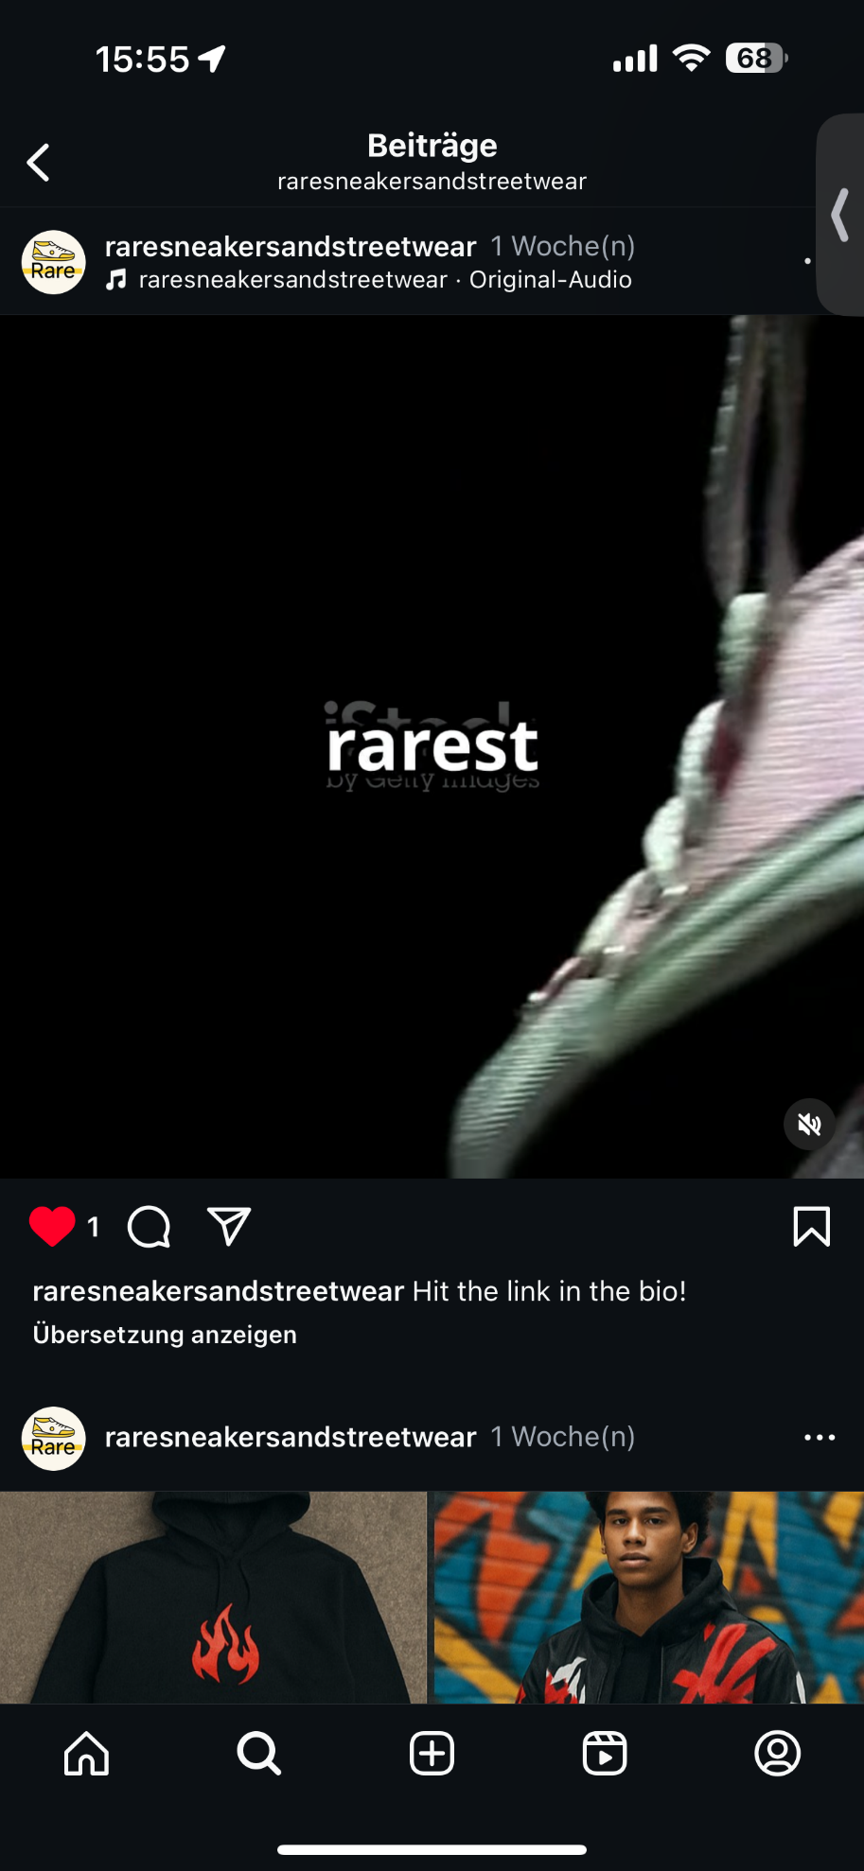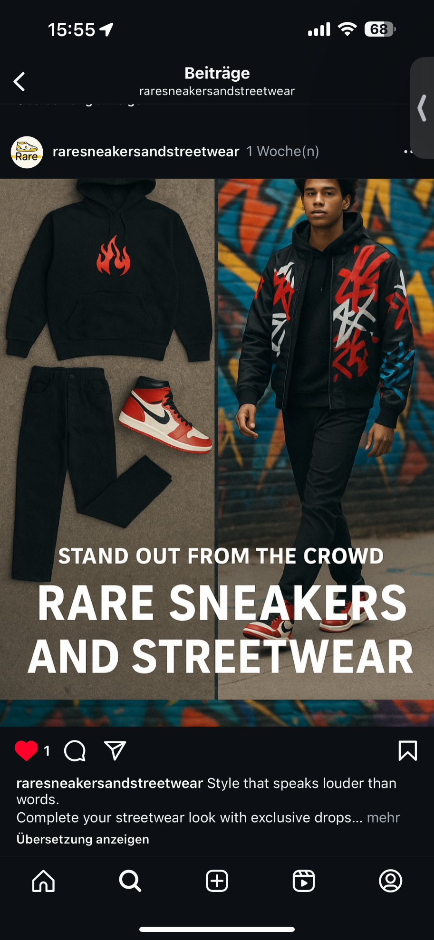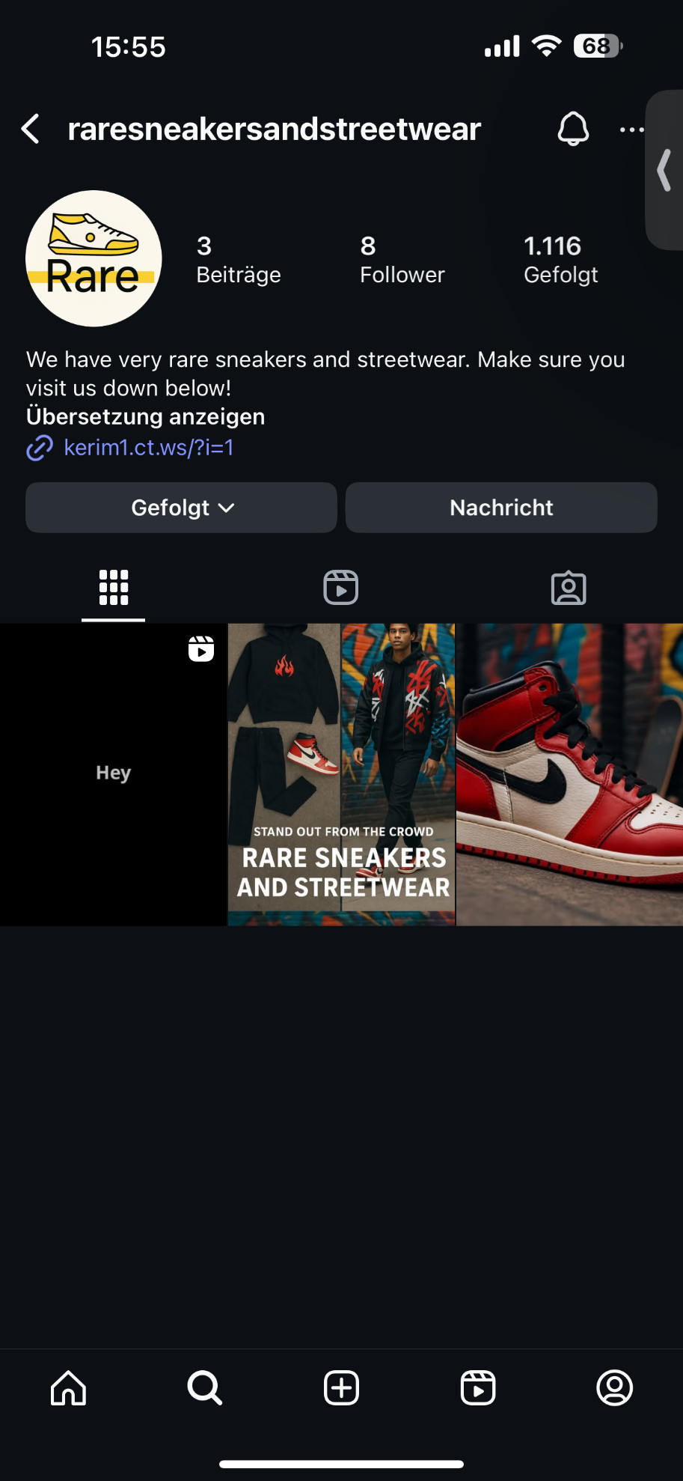

37

38

39

### 5. **Paid Advertising Campaigns**

### Facebook/Instagram Ads: Created for new drops and retargeting. Retargeting: For abandoned cart users with urgency-based copy.

### 

40

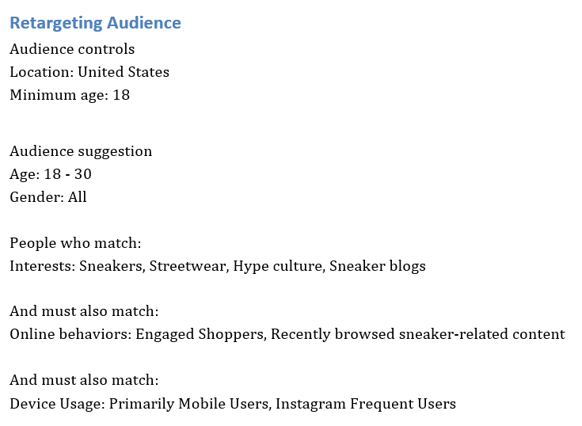

41

### 6. **Email Marketing**

Platform: Brevo  
Campaign: 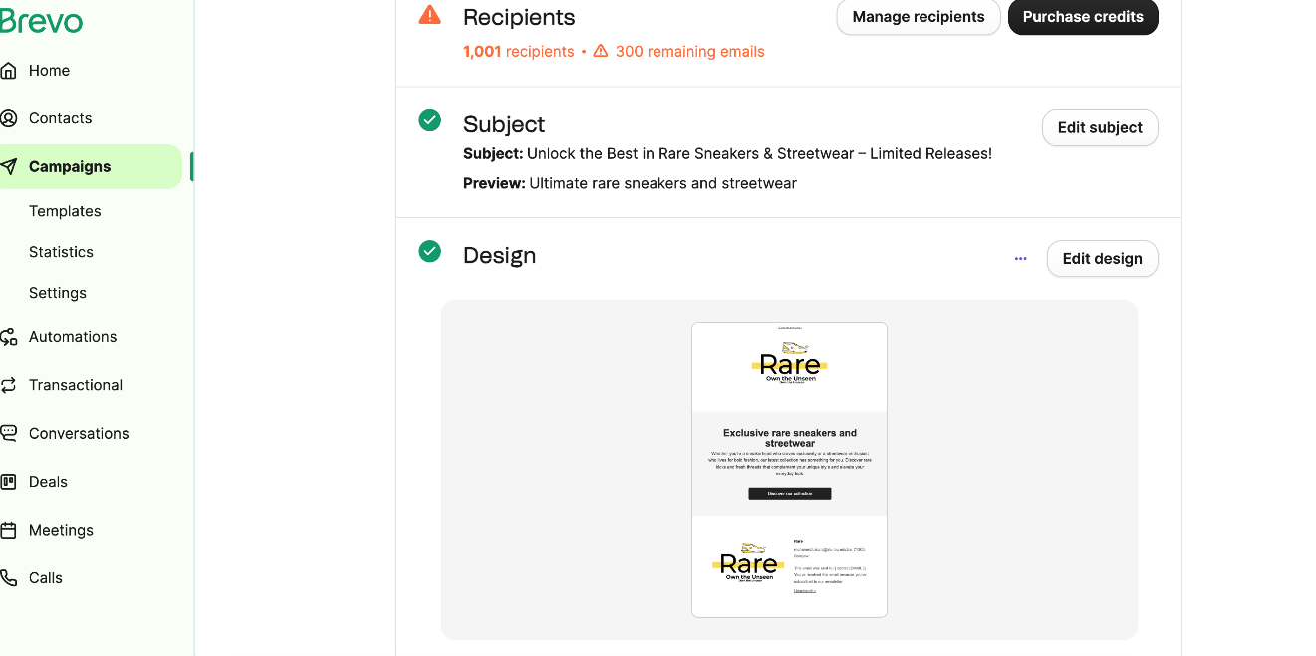

42

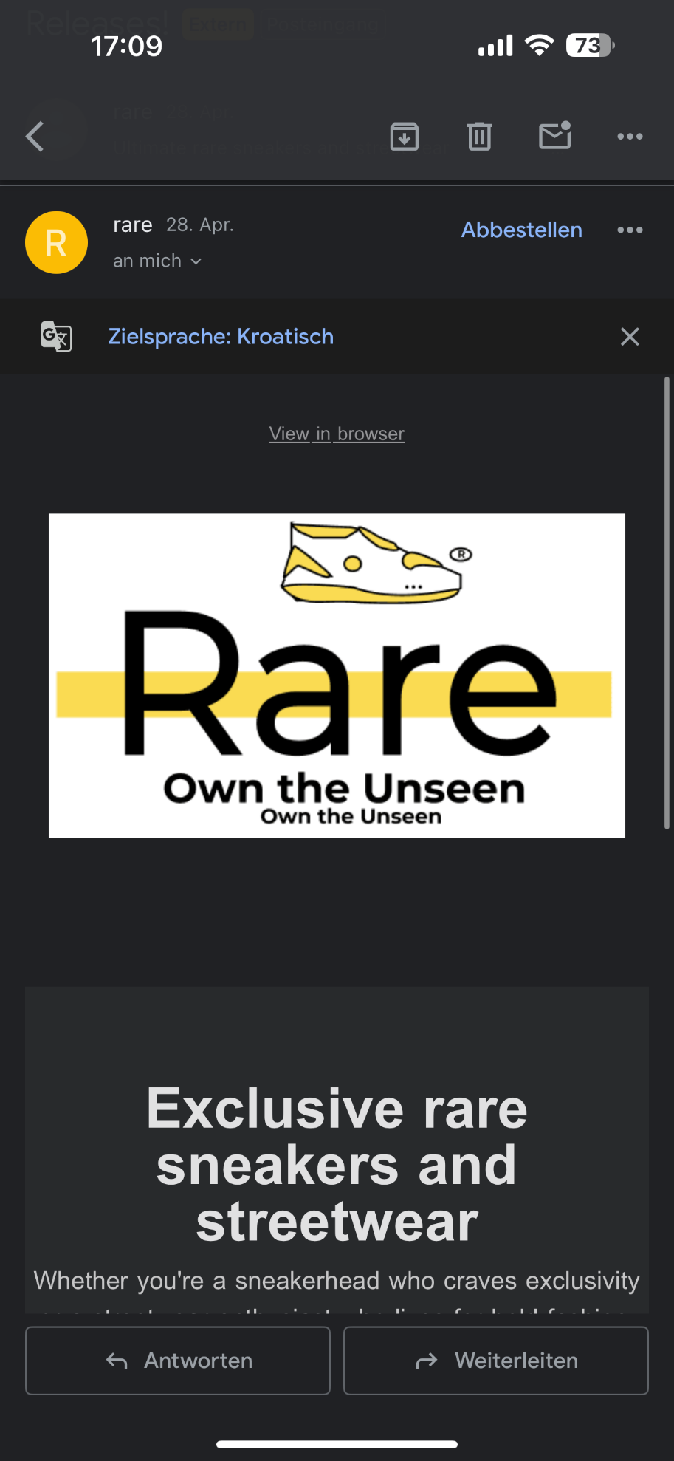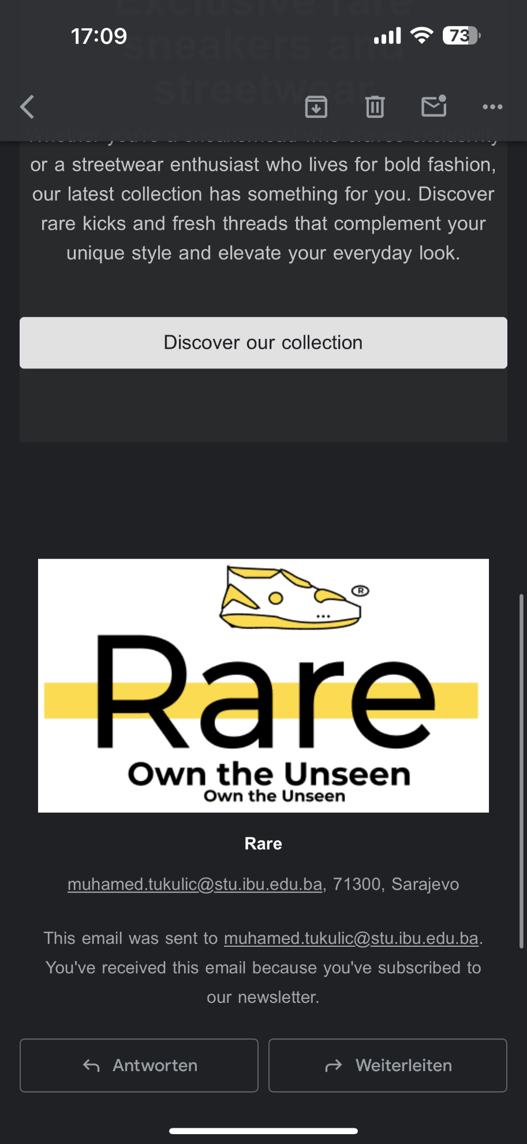

43

44

### **7. SMS Campaign**

Sent drop alerts to high-engagement users.  
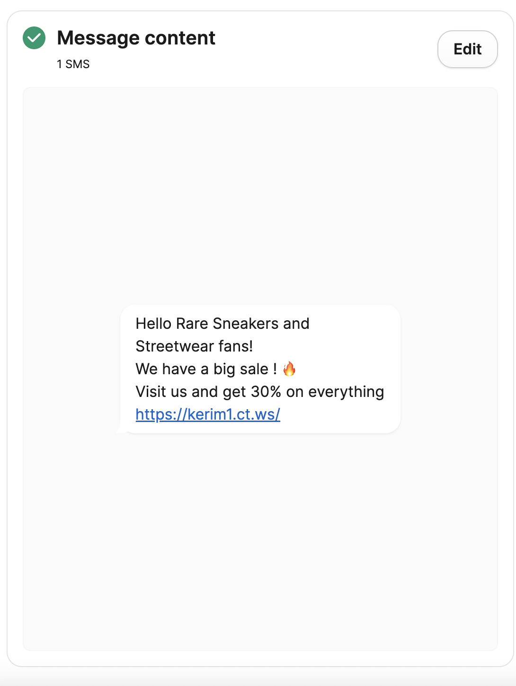

45

### 8. Google Analytics & Insights

GA4 tracking implemented.  
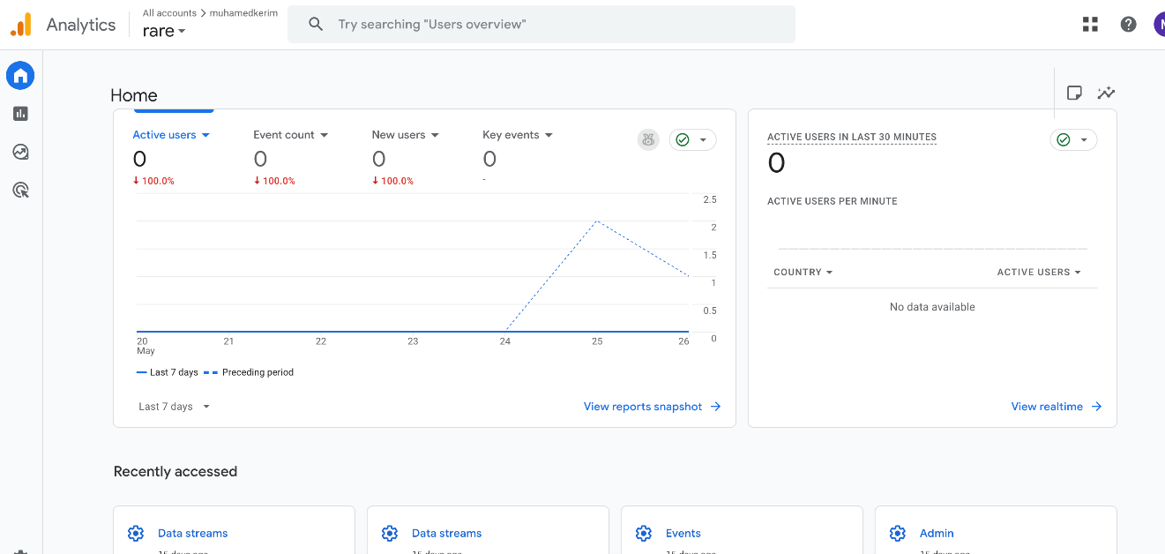

**Lessons Learned & Reflections**

**Technical Challenges**

Throughout Milestone 2, we encountered several technical hurdles:

**Plugin Conflicts:** Some plugins (e.g., security and design tools) caused minor layout or login issues until properly configured.

**Mobile Responsiveness:** Ensuring consistent layout across devices required multiple iterations and testing.

**Payment Integration:** Stripe and PayPal setups required sandbox testing and troubleshooting API credentials.

**Teamwork**

**What Worked Well:**

* + Clear division of tasks (e.g., design, backend, content) helped us stay organized.

46

* + Regular check-ins ensured alignment and fast problem-solving.

**What Could Be Improved:**

* + Some dependencies between tasks caused delays (e.g., waiting for product data before finalizing the catalog).
  + Better use of shared documentation could have streamlined our decision-making process.

**Time Management**

Initial setup took longer than expected due to debugging and plugin testing.

We learned the importance of buffer time for testing and optimization.

**What We’d Do Differently**

Start with a finalized sitemap and content structure earlier.

Choose all key plugins at the beginning to reduce backtracking.

Set up a staging environment for testing without affecting the live site.

Use a project management tool (like Trello or Notion) to visualize progress more effectively.

**SWOT Analysis & Future Opportunities**

**Strengths**

* Fully functional and secure WordPress e-commerce website
* Responsive design optimized for mobile and tablet users
* Clean UI with user-friendly navigation and product filtering
* SEO-ready with Yoast and optimized metadata
* Strong security foundation with 2FA, CAPTCHA, and firewall protection

**Weaknesses**

* Heavy plugin reliance can impact long-term performance and compatibility
* Design consistency still requires polish on certain pages

47

* Manual product management is time-consuming without automation

**Opportunities**

* **Mobile App**: Launch a native iOS/Android app for improved UX and notifications
* **AR Try-Ons**: Allow users to virtually try on sneakers using AR technology
* **Limited Drop Auctions**: Add a timed auction feature for exclusive product drops
* **User-Generated Content**: Allow users to post reviews with photos or video content
* **Affiliate System**: Enable sneaker resellers to earn commission through referral links

**Threats**

* High competition from established marketplaces like StockX and GOAT
* Changing e-commerce regulations and compliance (GDPR, data protection)
* Security risks like brute force attacks, phishing, or plugin vulnerabilities
* Potential scalability issues as traffic or product volume grows

48